MS SQL SERVER
Implementing and managing jobs in sql server 2014

Submitted to



BY



CIS, Wipro Limited

Document Details

Project Name | Innogy SE
Account | CIS
IT Component/Application Title | Implementing and managing jobs in SQL server 2005
Current Version | 1.0
List of Contributors | Pradipkumar Kansara, Kiran Bhalekar, Ayushi Gautam, Sivakumar Goud, Pramod Patil
Customer Contact Information

Version History
(All revisions made to this document must be listed in chronological order. All revisions must be approved. Review and Approval can be done by an internal source or by the customer)
Version | Date of Revision | Description | Author | Reviewed By | Approved By
1.0 | 29-08-2015 | Initial Draft | Kiran Bhalekar | Pradipkumar Kansara | Mahesh Keshatwar
1.1 | 04-09-2015 | Document Completed | Kiran Bhalekar | Pradipkumar Kansara | Mahesh Keshatwar
1.2 | 21-08-2016 | Updated document to standard format | Kiran Bhalekar | Pradipkumar Kansara | Mahesh Keshatwar
1.3 | 17-05-2017 | Wipro and Innogy Logo changed | Kiran Bhalekar | Pradipkumar Kansara | Mahesh Keshatwar
1.4 | 12-09-2017 | Updated document to Wipro Standard format with header and footer | Sivakumar Goud | Pradipkumar Kansara | Mahesh Keshatwar
1.5 | 30-11-2017 | Updated the document for SQL Server 2014 | Ayushi Gautam | Pradipkumar Kansara | Mahesh Keshatwar
1.6 | 25-12-2018 | Updated the content | Pramod Patil | Pradipkumar Kansara | Santosh Badiger

Document Distribution List
Sr.No | Name and Company | Purpose
1 | RWEIT-SQLDBA | Document is useful for managing jobs in SQL server 2014.

TABLE OF CONTENT
1. Purpose 1
2. Scope 1
3. Implementing And Managing Jobs 1
3.1 Create a Job 1
3.2 Schedule a Job 4
3.3 Running a Job: 7
3.3.1 Start a job: 7
3.3.2 Stop a Job: 9
3.3.3 Viewing and modifying a Job: 10
3.3.4 Viewing a Job: 10
3.3.5 Modifying a Job: 12
3.3.6 Deleting a Job: 12
3.4 Note: 14
4. Best Practice 16
5. Reference 16

Purpose
This document is prepared for the management and troubleshooting of SQL Server Database Administration Services.

Scope
This document is prepared for SQL Wipro sustenance team and provides the concepts, management and troubleshooting aspects of implementing and managing Jobs for the administration of the SQL Server database.

Implementing and Managing Jobs
A job is a specified series of operations performed sequentially by SQL Server Agent. A job can perform a wide range of activities, including running Transact-SQL scripts, command-line applications, Microsoft ActiveX scripts, Integration Services packages, Analysis Services commands and queries, or Replication tasks. Jobs can run repetitive tasks or those that can be scheduled, and they can automatically notify users of job status by generating alerts, thereby greatly simplifying SQL Server administration.
You can use SQL Server Agent jobs to automate routine administrative tasks and run them on a recurring basis, making administration more efficient.
You can run a job manually, or you can configure it to run according to a schedule.

Create a Job
To create jobs perform the following steps:
1. In the Object Explorer, connect to an instance of the SQL Server Database Engine and then expand that instance.
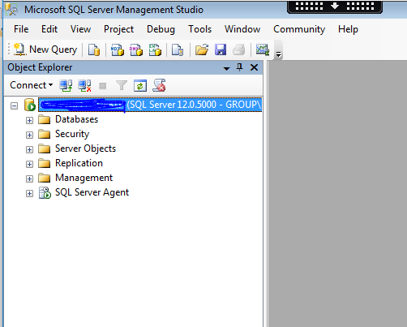
2. Expand SQL Server Agent.
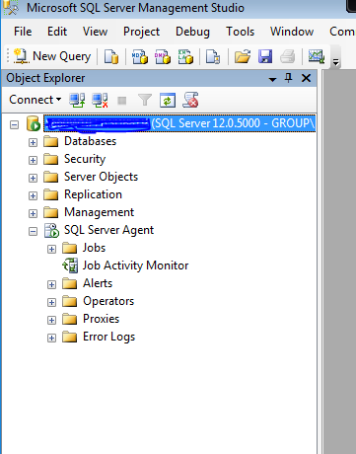

Right-click Jobs, and then click New Job.
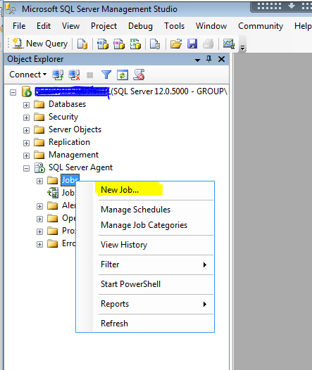
4. On the General page, in the Name box, type a name for the job.
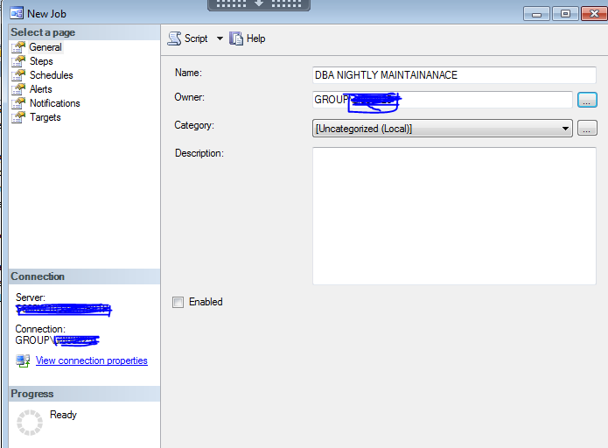
5. Clear the Enabled check box if you do not want the job to be run immediately following its creation.
6. In the Description box, enter a description of what the job does. The maximum number of characters is 512.

Schedule a Job

To schedule a job perform the following steps:

- In Object Explorer, connect to an instance of the SQL Server Database Engine, and then expand that instance.
- Expand SQL Server Agent, expand Jobs, right-click the job you want to schedule, and click Properties.
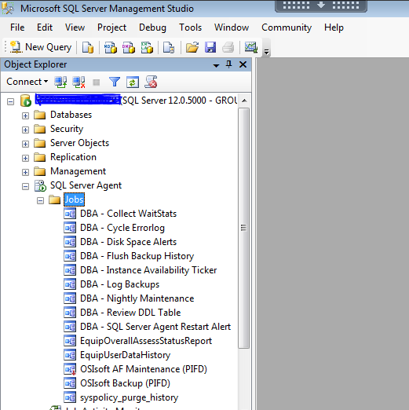

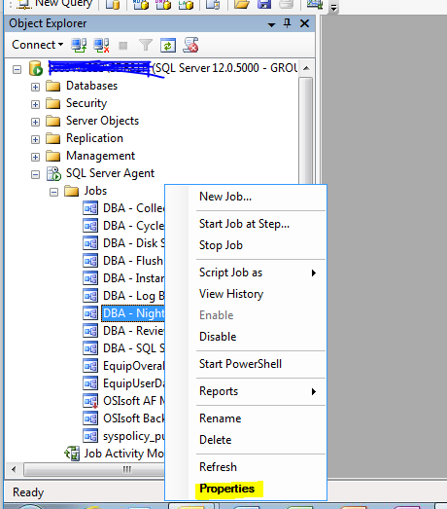
- Select the Schedules page, and then click New.
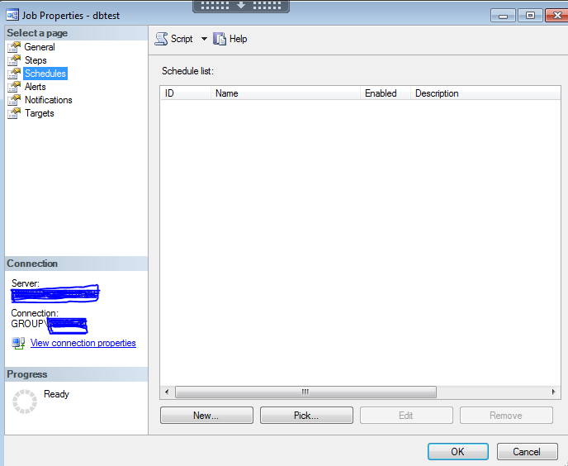

On clicking the “New…” button the “New Job Schedule” window will be displayed as follows:
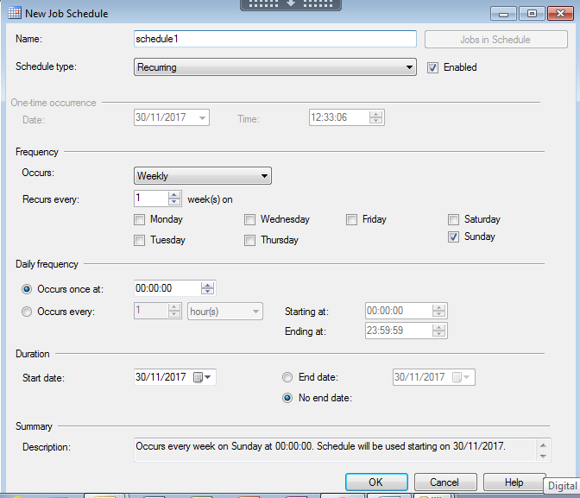
In the New Job Schedule window specify the following:
- In the Name box, type a name for the new schedule.
- Clear the Enabled check box if you do not want the schedule to take effect immediately following its creation.
- For Schedule Type, select one of the following:
  - Click Start automatically when SQL Server Agent starts to start the job when the SQL Server Agent service is started.
  - Click Start whenever the CPUs become idle to start the job when the CPUs reach an idle condition.
  - Click Recurring if you want a schedule to run repeatedly. To set the recurring schedule, complete the Frequency, Daily Frequency, and Duration groups on the dialog.
  - Click One time if you want the schedule to run only once. To set the One time schedule, complete the One-time occurrence group on the dialog.
Click OK to create the New Job Schedule. On clicking OK, the “Job Properties” window will display the newly created job schedule as follows:
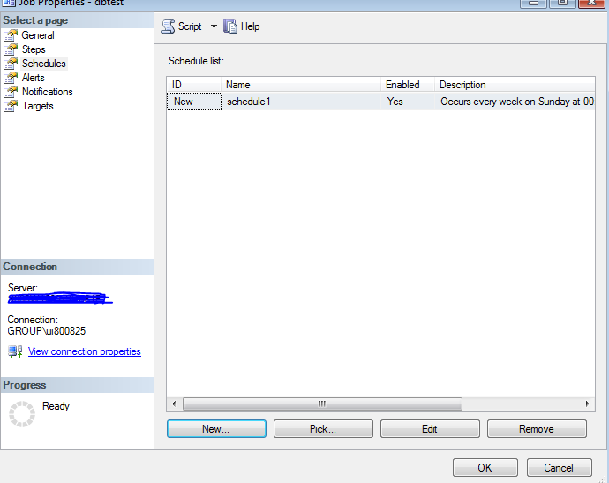
Click OK again.

Running a Job:

Start a job:
To start a job, perform the following steps:
- In Object Explorer, connect to an instance of the SQL Server Database Engine, and then expand that instance.
- Expand SQL Server Agent, and expand Jobs.
- Right-click the job you want to start, and then click Start Job.
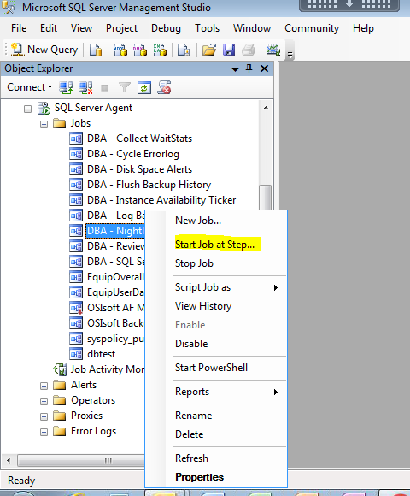

Stop a Job:
- In Object Explorer, connect to an instance of the SQL Server Database Engine, and then expand that instance.
- Expand SQL Server Agent, expand Jobs, right-click the job you want to stop, and then click Stop Job.
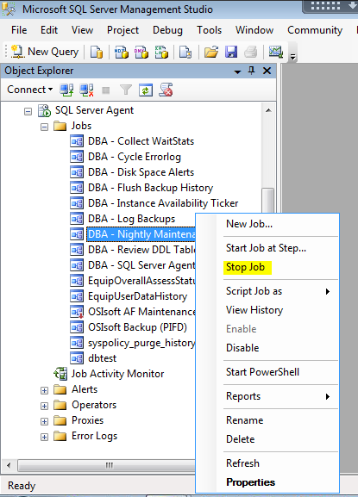

Viewing and modifying a Job:

Viewing a Job:
To view a job, perform the following steps:
- In Object Explorer, connect to an instance of the SQL Server Database Engine, and then expand that instance.
- Expand SQL Server Agent, and then expand Jobs.
- Right-click a job and then click Properties.
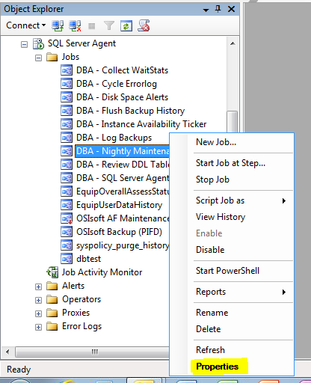
On clicking Properties, the following Job Properties window will be displayed.
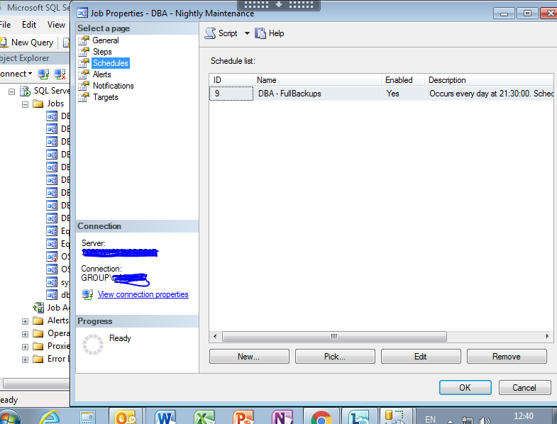

Modifying a Job:

- In Object Explorer, connect to an instance of the SQL Server Database Engine, and then expand that instance.
- Expand SQL Server Agent, expand Jobs, right-click the job you want to modify, and then click Properties.
- In the Job Properties dialog box, update the job's properties, steps, schedule, alerts, and notifications using the corresponding pages.

Deleting a Job:

- In Object Explorer, connect to an instance of the SQL Server Database Engine, and then expand that instance.
- Expand SQL Server Agent, expand Jobs, right-click the job you want to delete, and then click Delete.
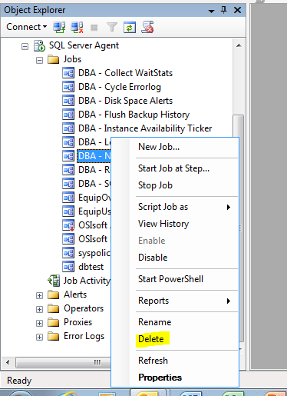
- In the Delete Object dialog box, confirm that the job you intend to delete is selected.
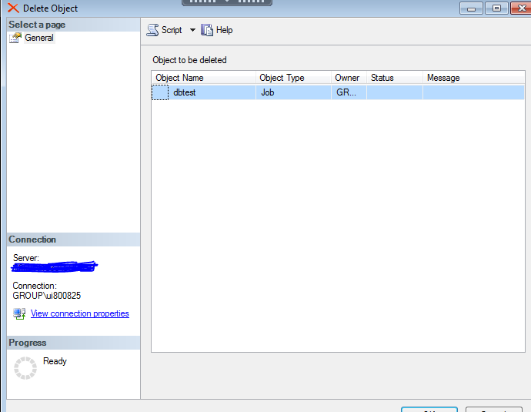
- Click OK.

Note:

1. It is prerequisite to start the SQL Server Agent service before a job is scheduled.
To start the SQL Server Agent service, perform the following steps:

- Go to Start > Run > services.msc > SQL Server Agent

b) The SQL Server Agent services will be displayed as follows:
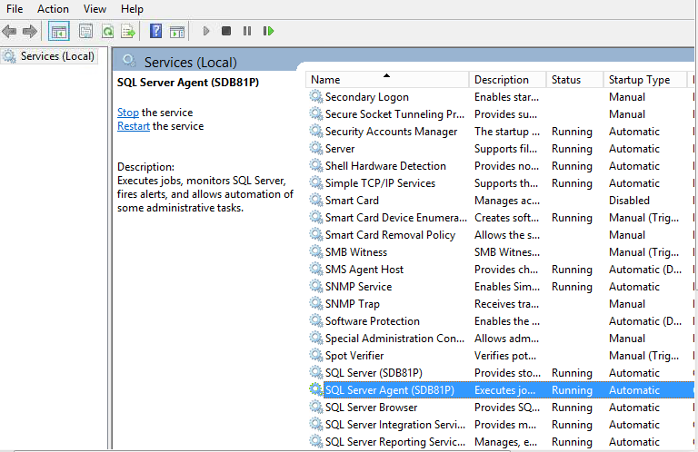
Now right click on the SQL server Agent service for Services and Connections
To start the SQL Server Agent
Startup Type: it should be Automatic
Service Status: Running

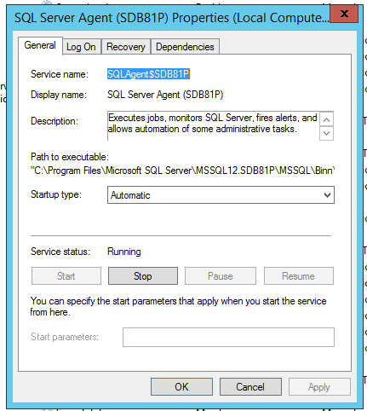

Click “Start” to start the SQL Server Agent service.

2. While starting a job, depending on server and number of jobs any one of the following can be done:
  - If you are working on a single server, or working on a target server, or running a local server job on a master server, right-click the job you want to start, and then click Start Job.
  - If you want to start multiple jobs, right-click Job Activity Monitor, and then click View Job Activity. In the Job Activity Monitor you can select multiple jobs, right-click your selection, and click Start Jobs.
  - If you are working on a master server and want all targeted servers to run the job simultaneously, right-click the job you want to start, click Start Job, and then click Start on all targeted servers.
  - If you are working on a master server and want to specify target servers for the job, right-click the job you want to start, click Start Job, and then click Start on specific target servers. In the Post Download Instructions dialog box, select the “These target servers” check box, and then select each target server on which this job should run.
3. While stopping a job, depending on server and number of jobs any one of the following can be done:

- If you want to stop multiple jobs, right-click Job Activity Monitor, and then click View Job Activity. In the Job Activity Monitor, select the jobs you want to stop, right-click your selection, and then click Stop Jobs.
- For a multiserver job, a STOP instruction for the job is posted to all target servers of the job.
4You can only view, modify, delete jobs, only if you are a member of the sysadmin fixed server role. Members of this role can view, modify and delete all jobs.

5 While deleting jobs, if there are multiple jobs then perform the following steps:
- In Object Explorer, connect to an instance of the SQL Server Database Engine, and then expand that instance.
- Expand SQL Server Agent.
- Right-click Job Activity Monitor, and click View Job Activity.
- In the Job Activity Monitor, select the jobs you want to delete, right-click your selection, and choose Delete jobs.

Best Practice
- If you want to test a job before it is scheduled to run, disable the job.

Reference

- http://msdn2.microsoft.com/en-us/library/ms186273.aspx
- http://msdn2.microsoft.com/en-us/library/ms190268.aspx
- http://msdn2.microsoft.com/en-us/library/ms175138.aspx
- http://msdn2.microsoft.com/en-us/library/ms191439.aspx
- http://msdn2.microsoft.com/en-us/library/ms190741.aspx
- http://msdn2.microsoft.com/en-us/library/ms190774.aspx
- http://msdn2.microsoft.com/en-us/library/ms180776.aspx

